Standard of Operations

Hulse Research Lab

December 12, 2021

Shepherd Center Crawford Research Institute

Jessica Gilliam

Table of Contents

Lab Instrumentation 4

I. Lab Manuals 4

II. Extra Cords and Instrumentation 4

Analogue to Digital Converter (ADC) CED 1401 4

I. Device Setup 4

II. Specifications 4

Motion Lab Systems MA300 DTU 5

I. Device Setup 5

II. Specifications 5

GRASS x88s 5

I. Device Setup 5

II. Specifications 6

Goniometer 6

I. Device Setup 6

II. Specifications 6

Pinch Dynamometer 6

I. Device Setup 6

II. Specifications 7

III. Pinch Meter Repair 7

Grip Dynamometer 10

I. Device Setup 10

II. Specifications 10

Xsens 11

I. Device Setup 11

II. Specifications 17

Spike 17

I. Sequencer File 17

II. Specifications 19

Signal 19

I. Device Setup 19

II. Specifications 19

GitHub 19

I. Device Setup 19

II. Specifications 20

# Lab Instrumentation

### Lab Manuals

Lab manuals are in the bottom drawer of the first desk in the office space. This contains all current and old lab manuals for devices used in the lab.

Additional lab manuals are located here: S:\CLIN_REA\Hulse Lab\Equipment and Software\current device manuals

### Extra Cords and Instrumentation

The metal lab closet on the 3rd floor and the metal closet in the yoga room contain extra BNC cables, power cords, old device equipment, and current study equipment.

# Analogue to Digital Converter (ADC) CED 1401

### Device Setup

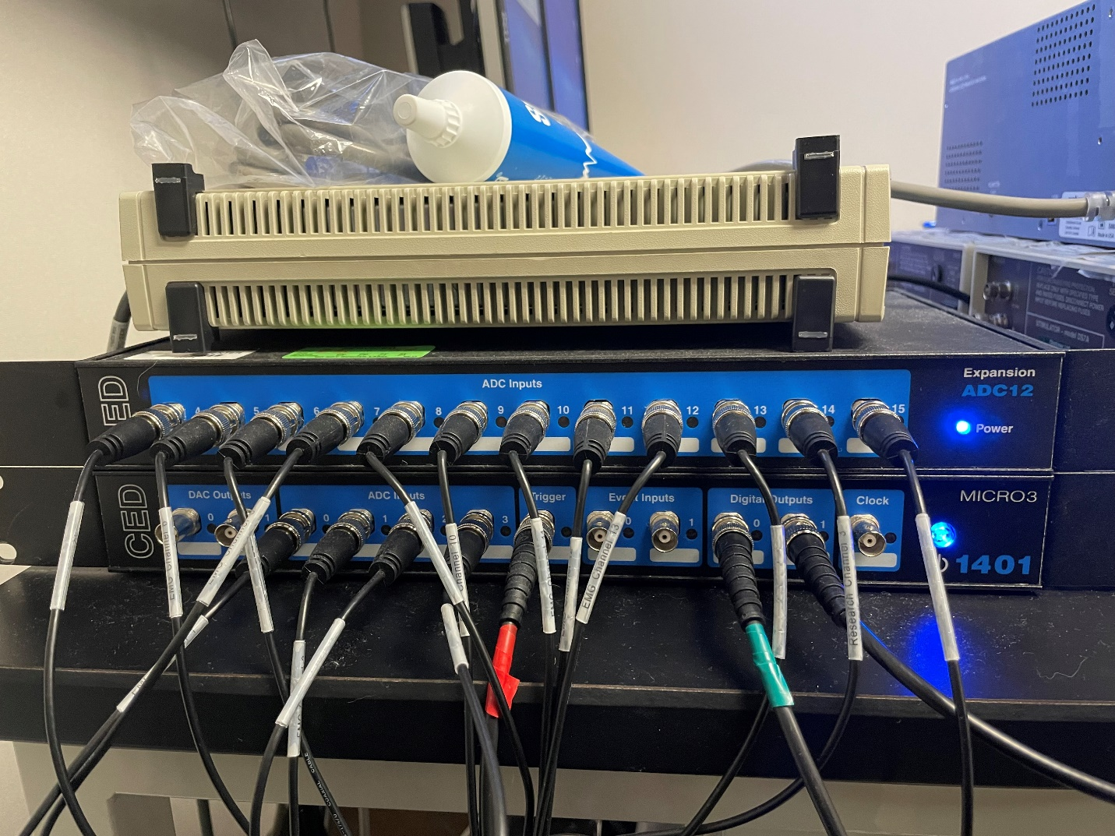

ADC Inputs 0-15 (BNC Cables are one more than the ADC Inputs on the box *see in figure BNC Channel 10 and ADC Input 9) The BNC Cord Channel numbers correspond to the Motion Lab systems box for EMG plug ins

### Specifications

# Motion Lab Systems MA300 DTU

### Device Setup

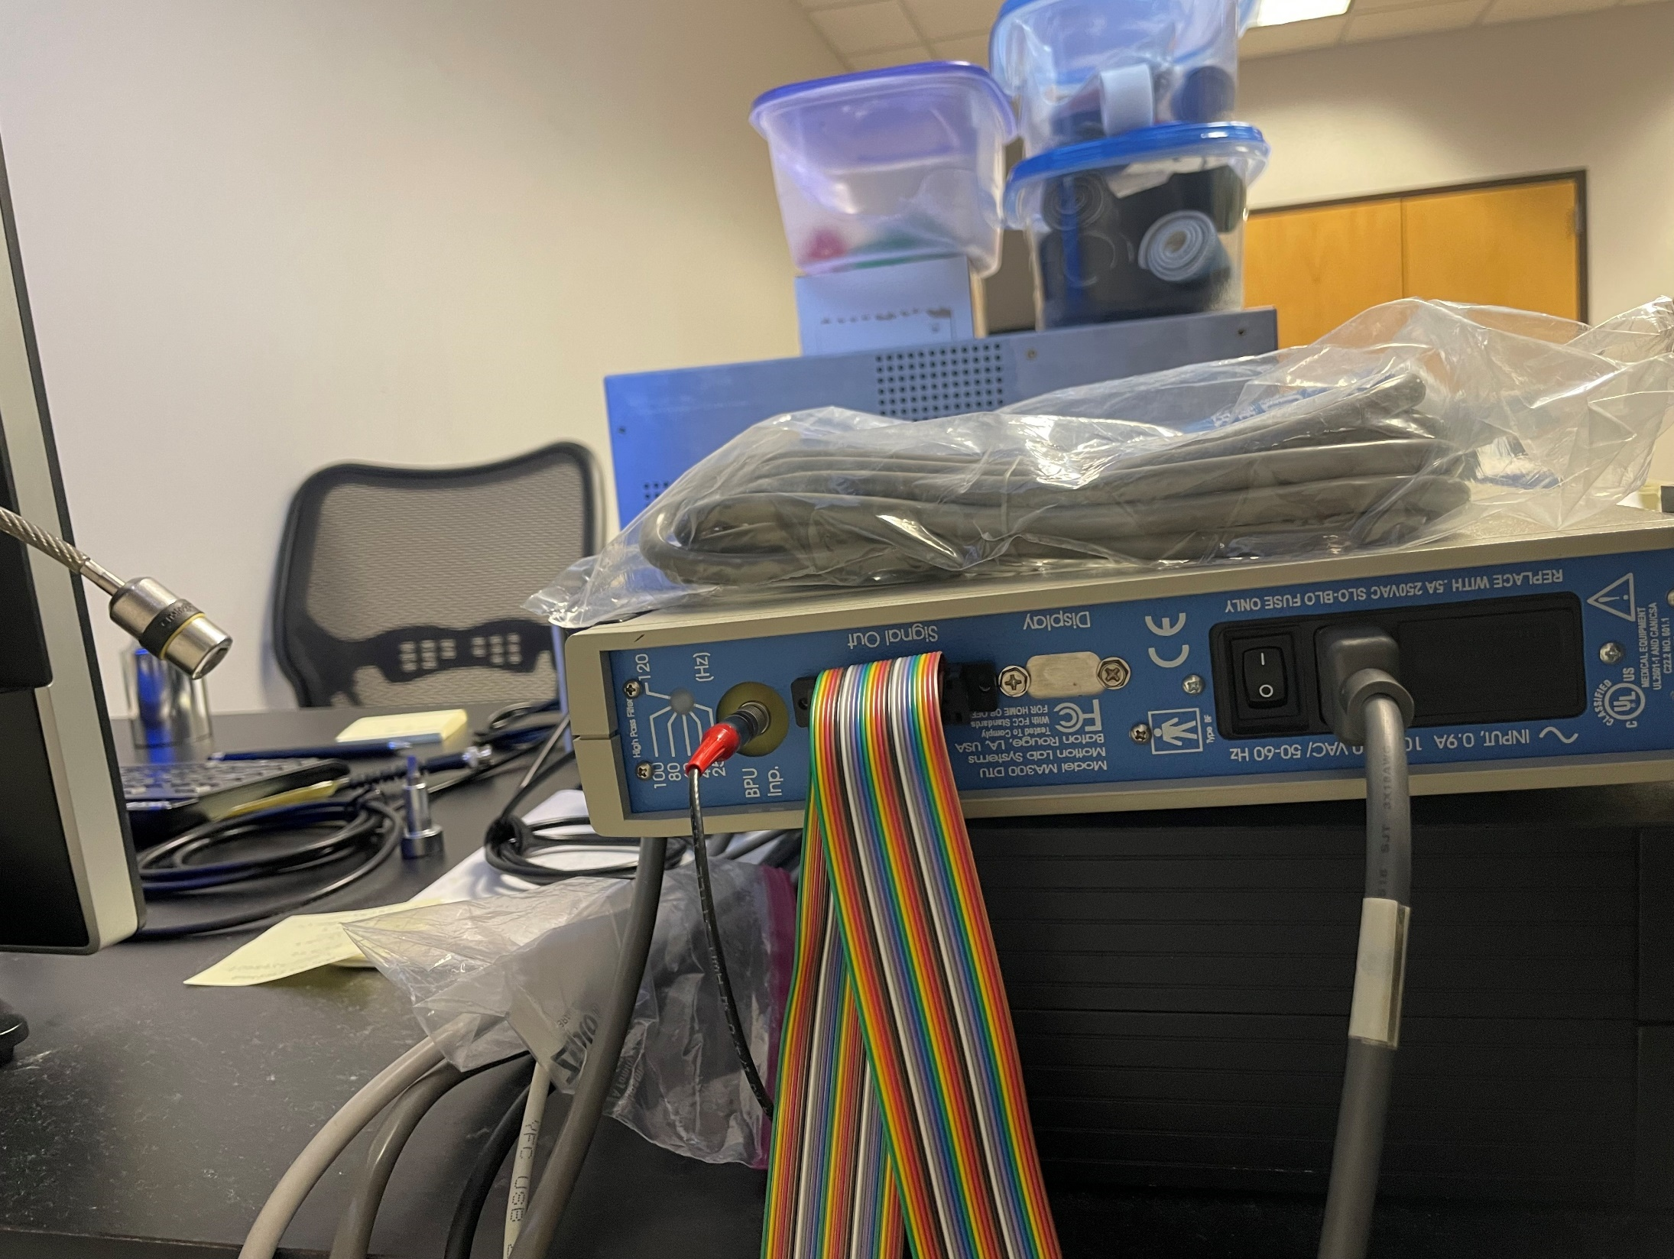

### Specifications

# GRASS x88s

### Device Setup

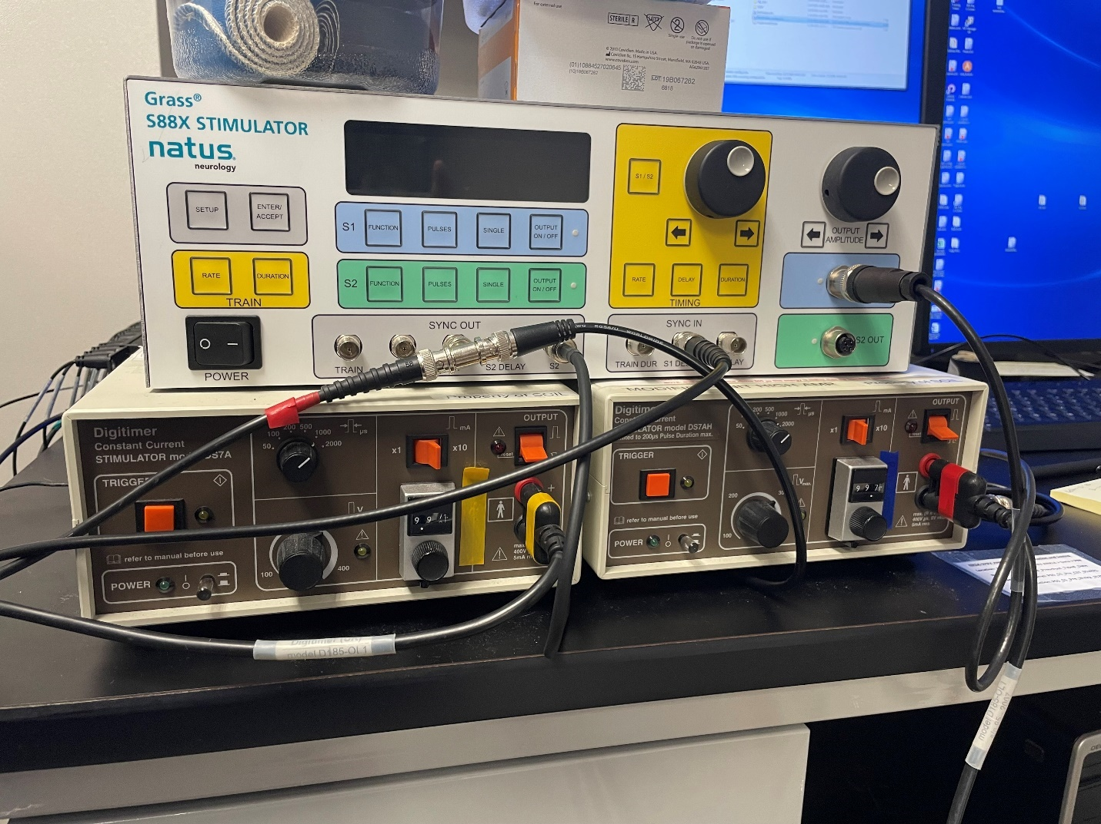

**S2**

**S1**

Red Arrow – Sync In – allows for Pulse Train Sequencer File to be used

Brown Arrow – S1 Out – Can see the electrical signal if routed back to ADC Input channel in Spike2

Evan’s study – Grass needs to be set to S1 Delay/ Output 1 for S1 ON; S1 Out plugs into 13 ADC input

### Specifications

# Goniometer

### Device Setup

Goniometer box is used with pinch meter – the X/Y need to be rotated/adjusted to read the X and Y directions

### Specifications

# Pinch Dynamometer

### Device Setup

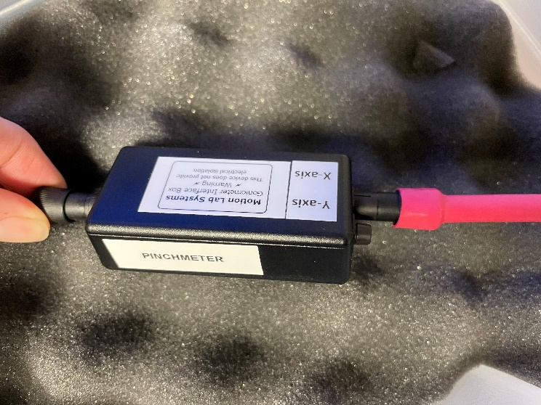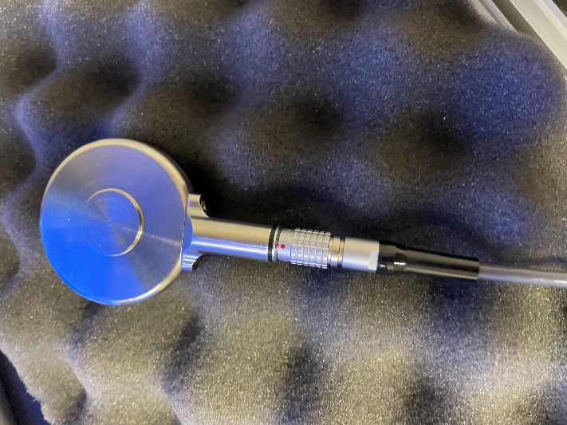

Device set up of the Pinch meter for Anastasia’s study – goniometer port in the x (low speed A&B) replacement cord can be found in pinch meter repair kit.

BPU input cable from Motion Lab systems Box plugs into Motion Lab Backpack (Red cable)

### Specifications

### Pinch Meter Repair

LEMO Cable wiring:

RED Supply Volts

BLACK Common or Ground

BROWN differential output +ve

ORANGE differential output -ve

Use the following diagram to match the wires with the proper pins:

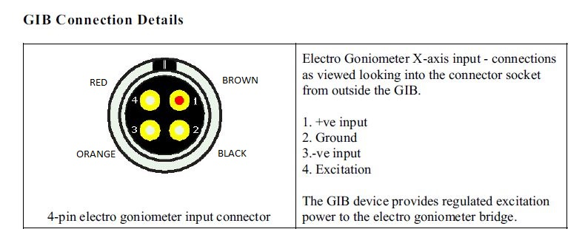

**GIB (Goniometer Interface Box)**

1. +ve input – BROWN (differential output +ve)

2. Ground – BLACK (Common or Ground)

3.-ve input – ORANGE (differential output -ve)

4. Excitation – RED (Supply Volts)

**Male Plug-In side view:**

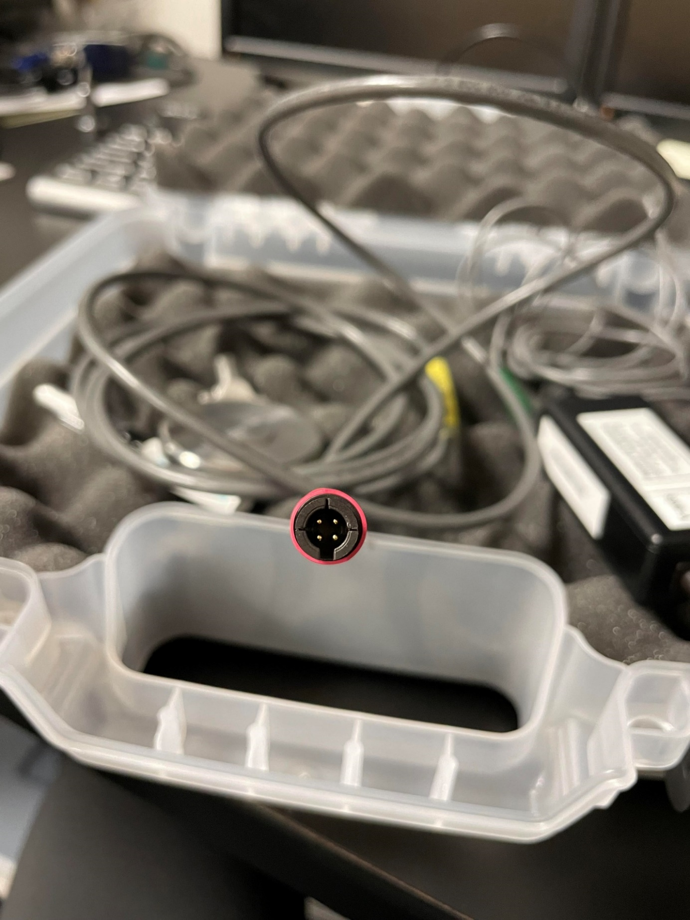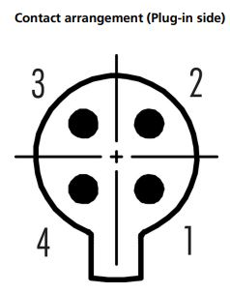

**Female Plug-In side view:**

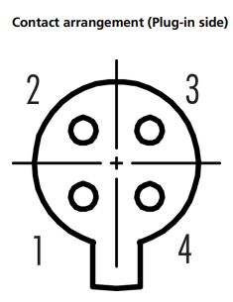 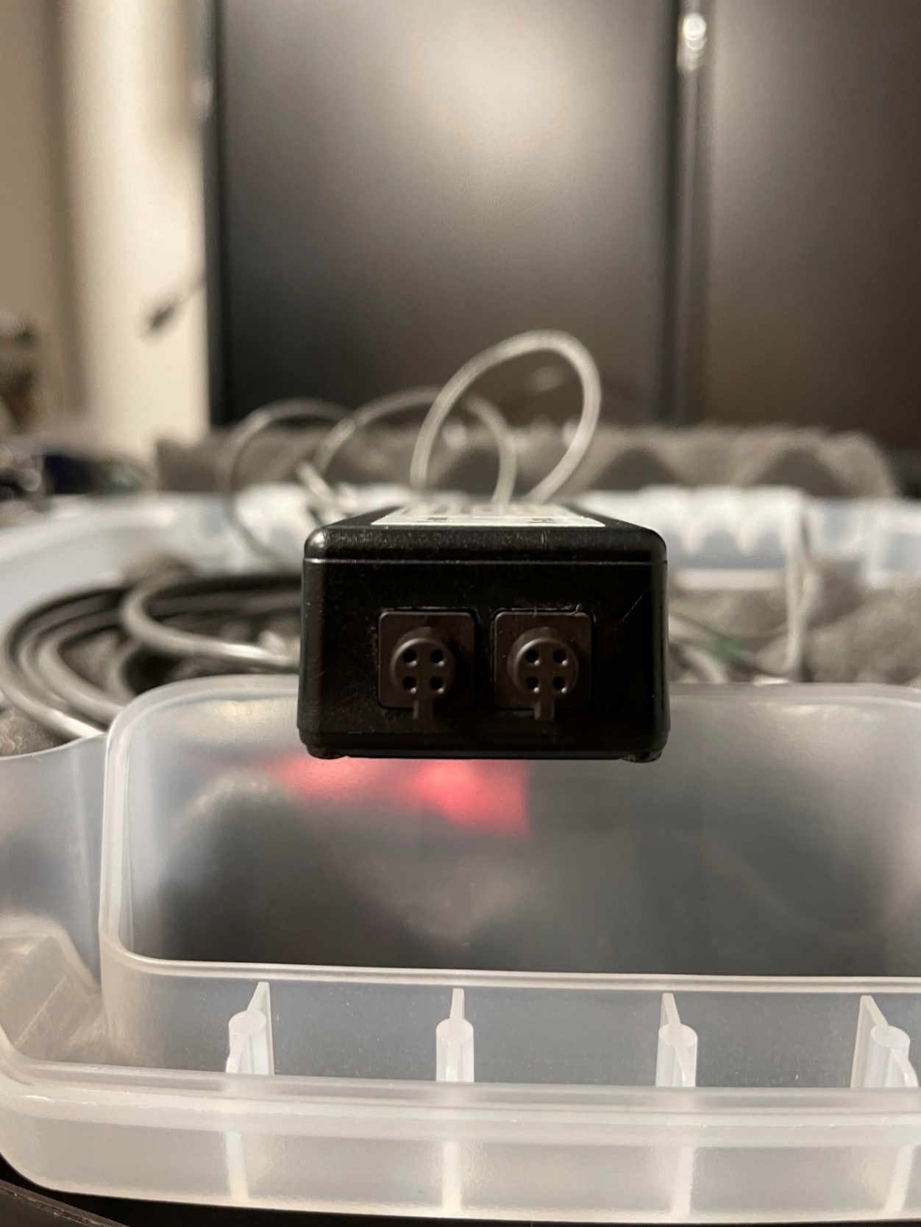

**NOTE: When soldering wires to pins it will be on the back side of the male connector and the orientation will follow the female connector plug-in side. See picture below:**

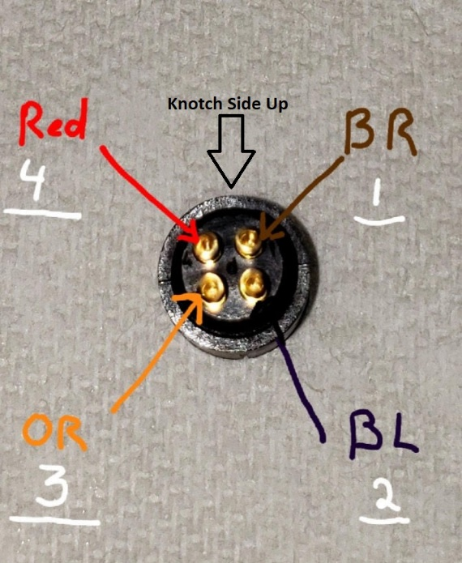

Link to Male Binder Connector: <https://www.binder-usa.com/us-en/products/subminiature-circular-connectors/snap-in-ip40/cable-plug-connector-with-strain-relief#0997677004>

Additional Pictures of soldered cable connection:

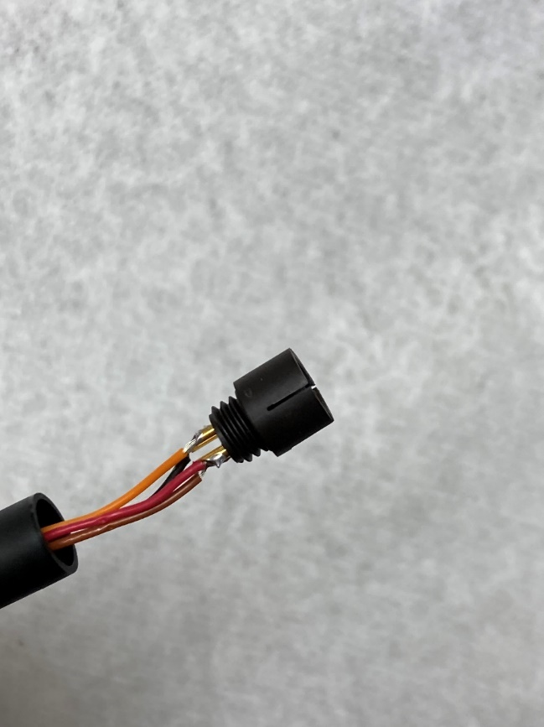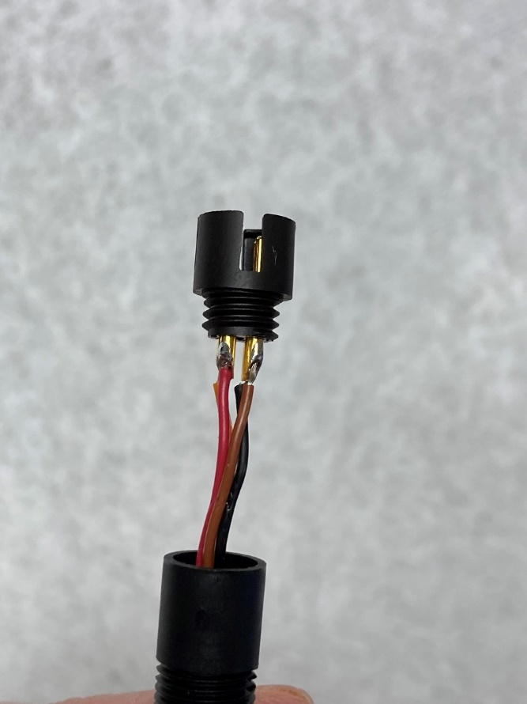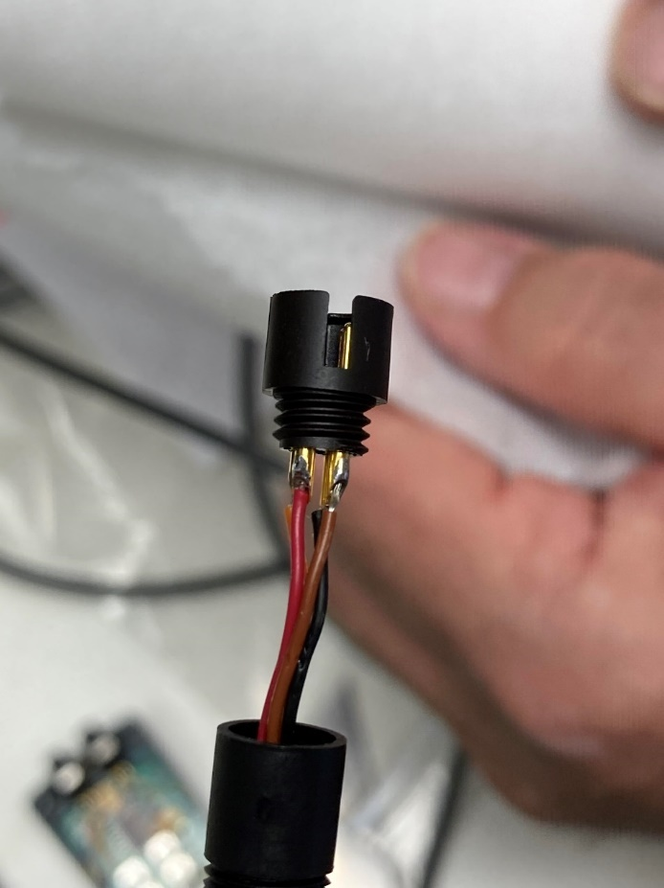

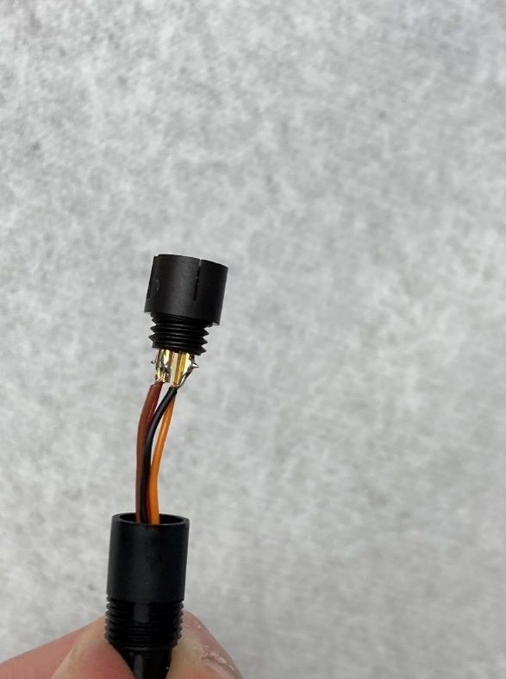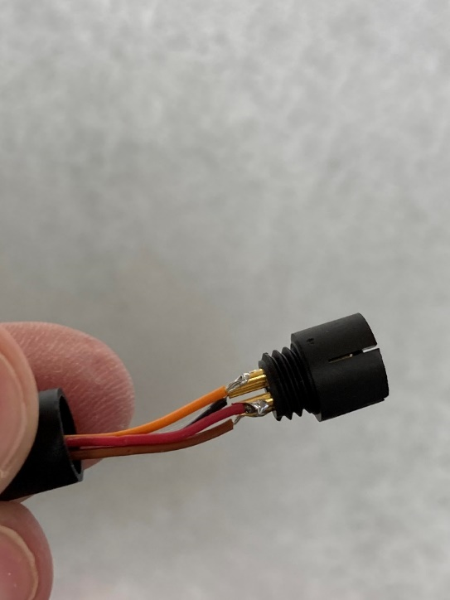

# Grip Dynamometer

### Device Setup

Set up does not differ from the manual

### Specifications

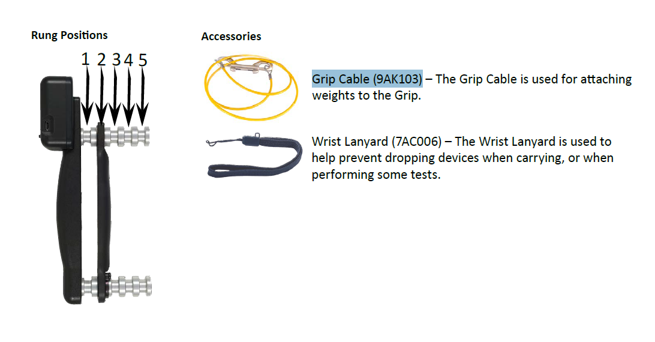

Hanging weight to test calibration of the device

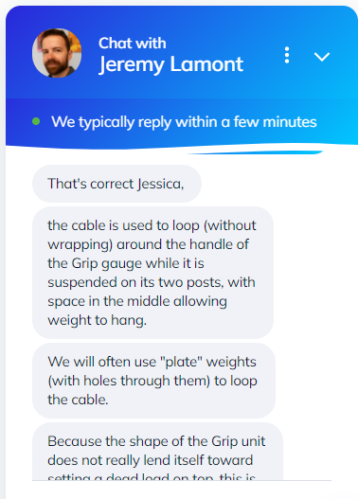

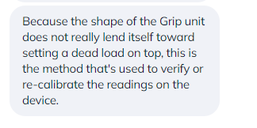

Need to purchase a bar weight and determine differences between the two goniometers. Does it change if calibrated back to factory settings?

# Xsens

### Device Setup

USB Xsens Dongle has the Xsens License on it

Must plug in the Xsens

When putting sensors on, make sure you can read the Xsens label (vertical) all sensors should be aligned the same way.

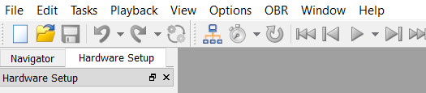

Click white paper to start new document

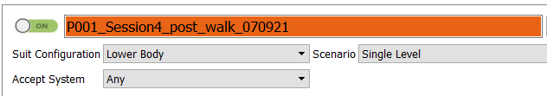

For motion capture Full Body (60Hz) and Lower Body (100Hz) this is automatically collected but is important later on for post-processing in Matlab

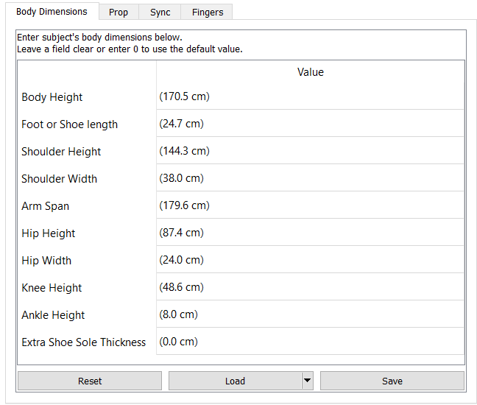

Body Measurements for new participant – make sure to also get the shoe thickness, if doing a drop test put the shoe thickness to zero

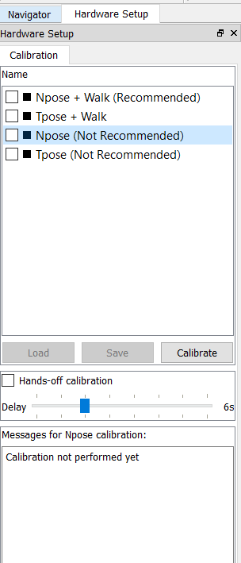When Calibrating select the Npose (not recommended) the box will not check and select calibrate then start

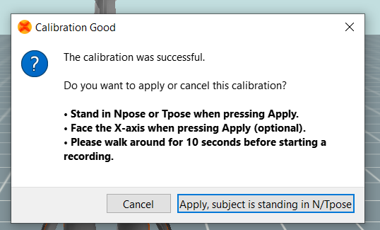

This is the next image you will see and if the Calibration shows “Good” accept the calibration and move forward

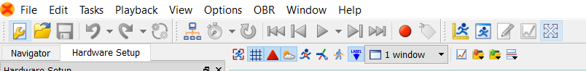

Click the wrench to view the side panel

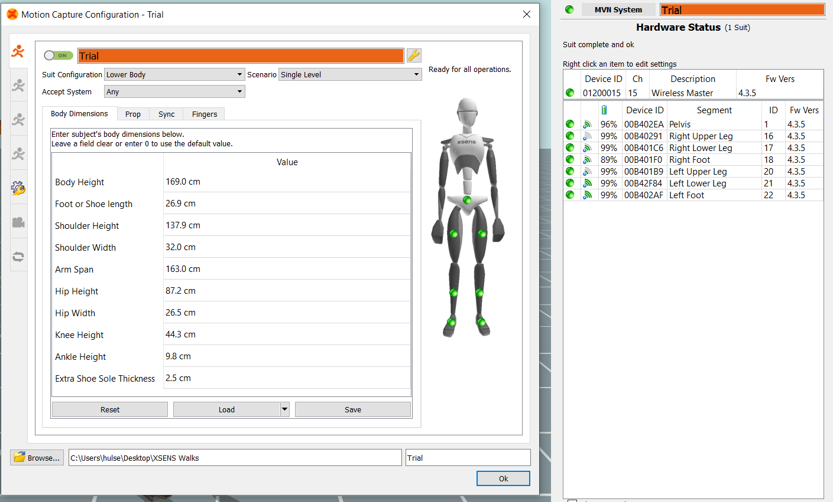

The side panel can help to visually see all of the sensors. Right click the segment name and you can accept/reject and then from there you can rename the segment. This is helpful when a sensor is not charged or not working, and you can use the prop instead. Always remember to change this back later.

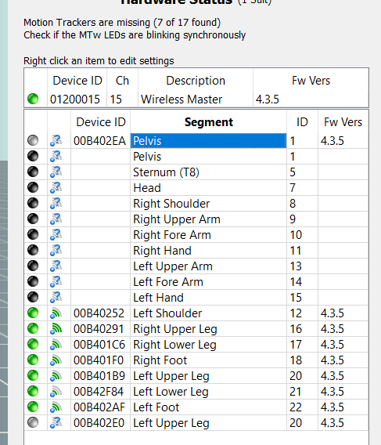

Select graph (red line)

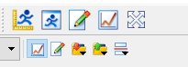

Trial tree

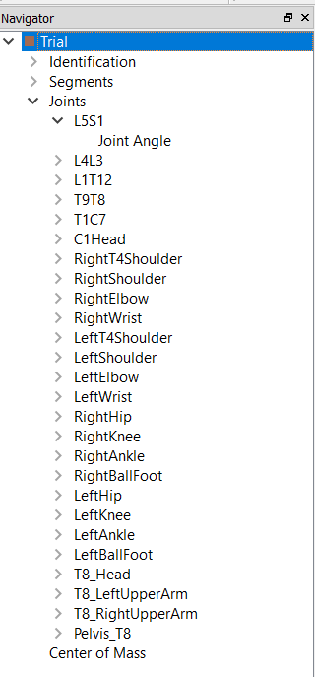

Measuring tool (yellow ruler)

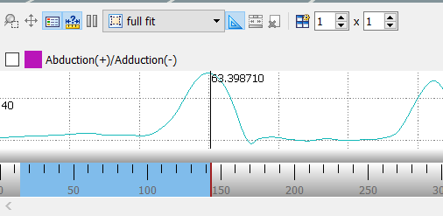

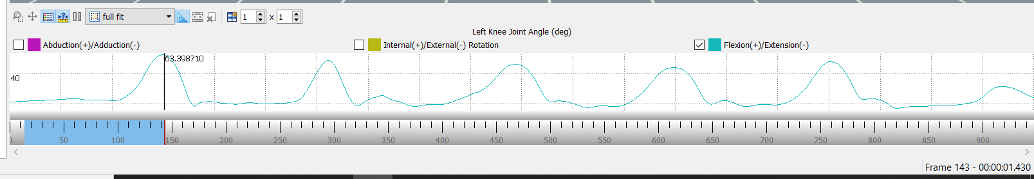

Frame and time bottom right. You have the ability to click through what angles you want to see. In order to see the graph of a joint or a segment you have to drag this in from the trial tree. The bottom right corner shows the frames and time – this is helpful when validation needs to be done from a matlab analysis.

You can also trim the files by selecting a section and exporting it. When exporting you can rename it and you MUST change the exporter type to .mvnx (keep all values selected so that you have this in the future)

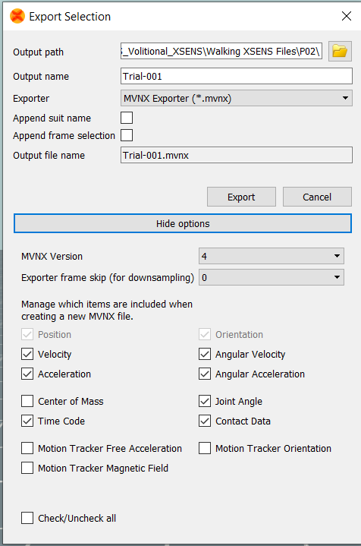

### Specifications

# Spike

### Sequencer File

Pulse_Train.pls paired with All_electrode Channels

Allows Spike2 to run the GRASS s88x

The GRASS needs to be put on S1 Delay with S1 output button pressed with light on.

BNC cables from S1 stimulation unit can be connected to the ADC – capabilities to see the pulse being generated from the GRASS on Spike2

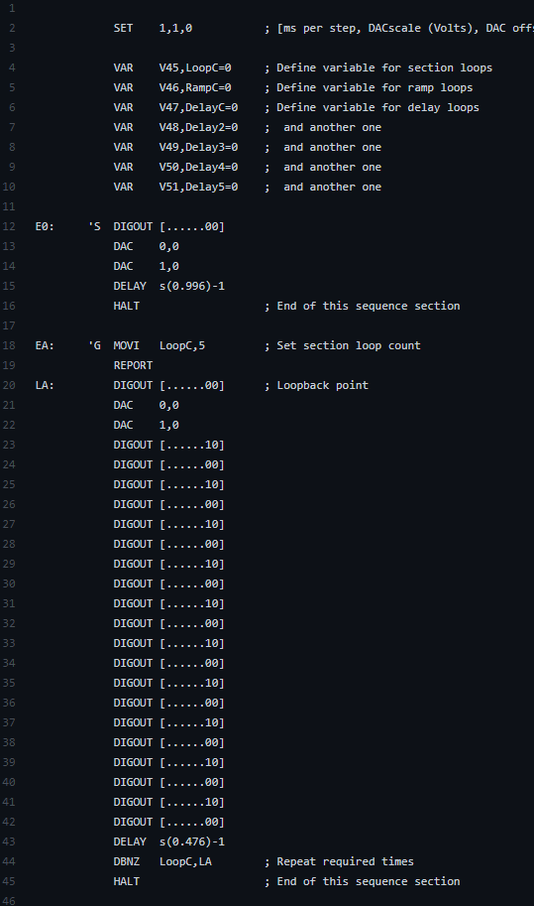

### Specifications

# Signal

### Device Setup

### Specifications

# GitHub

### Device Setup

GitHub is an easy MATLAB file storage and source code editor. Allows for the ability to move files/data easily from desktop to laptop as long as there is MATLAB software uploaded. The source coding shows edits made to each code. Therefore, if an edit was made, or a merge was implemented this can be easily identified.

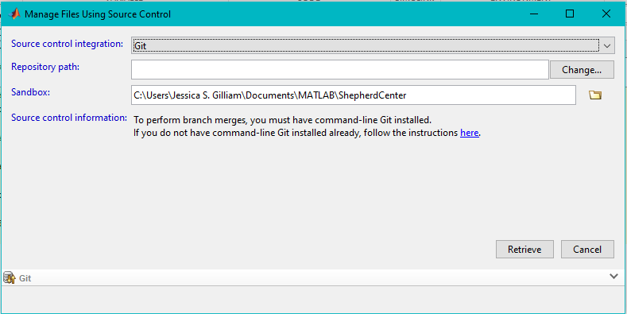

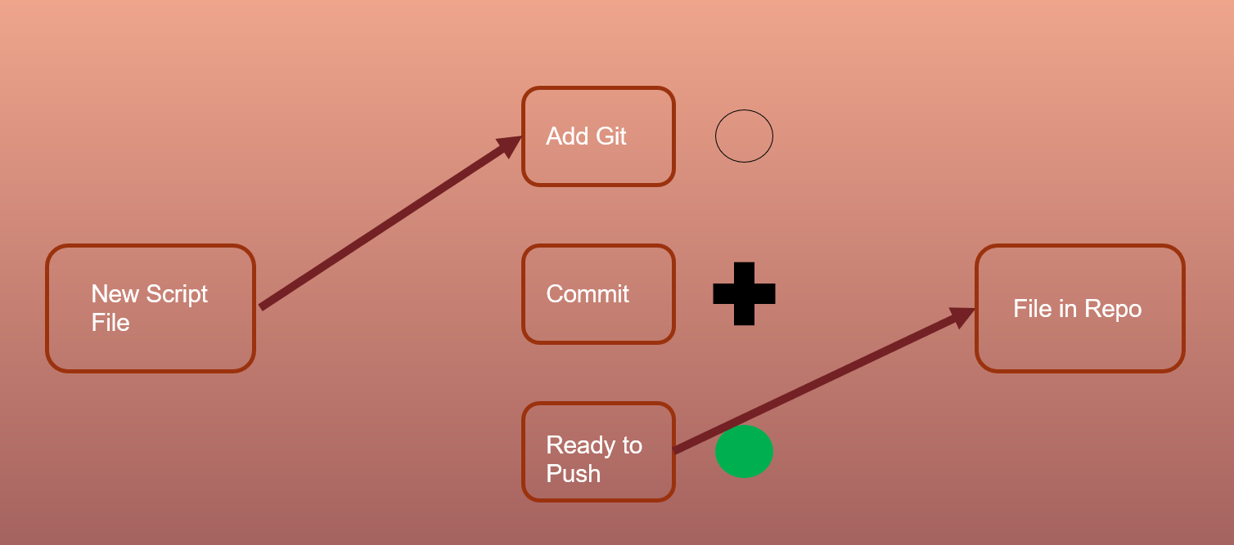

Following each day of code editing, process for source code includes, adding new codes to git, committing new codes to git, pushing the codes out to the server. If a code needs to be committed, a black cross will show next to the status. If a green circle is shown, the code is fully up to date with the system server. If codes are not added to the server before they are pulled down and edited somewhere else, the two code versions will be on different commitment lines and it will be necessary to revert changes made to a local server before adding back to the main.

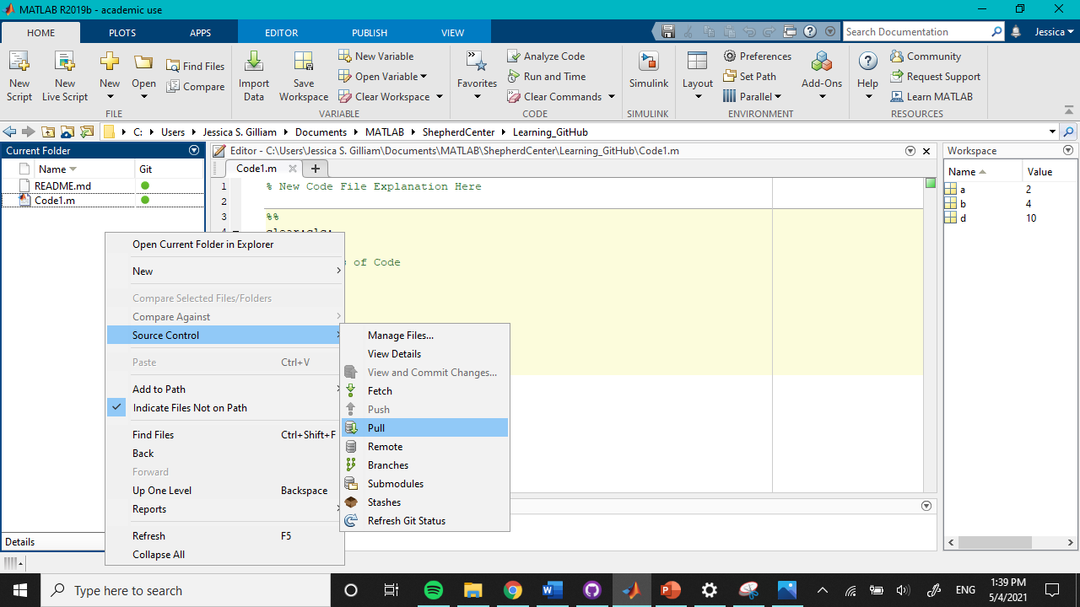

If code has been updated in one local repository but not another. Pull data down from the main before any editing begins.

### Specifications

Repositories:

* DoD
  + Evan
  + MCD_pre_Thenar
  + Subclinical EMG Analysis
  + TMS
  + UE Spasticity
* VETA
  + Conversion tools
  + Data
  + Figures
* RMP
  + J_Codes (Jasmine Codes)
  + Jasmine_Data
  + SCIMS
  + TSS_Ankle_1_12 (Jasmine Codes
  + Xsens_Jas
* Yoga_Room_Files
  + Dod_Evan (Pulse Train Grass Stimulation)

Each repository is linked to MATLAB except for Yoga_Room_Files – this is a manual upload and should be added to consistently to keep backup copy of system files